 | Filing Reference : |  | GG/COMS/TS.2/17
 | Document Title : |  | Use-Case Realization Report (Analysis)  Start Cylinder Production Process
 | Version : |  | 1.0
 | Prepared By : |  | Koh Ming Jin
 | Date Created : |  | Monday, Apr 29th, 2011
Approved By :
 |  | Tran Ba Tien |  | Date
 |  | Project Manager |  | 29th Apr 2011
©2011 [Hoang Kim joint stock Company].
The information contained in this document is the property of [Hoang Kim joint stock Company]. The contents must not be reproduced, wholly or in part, for purposes other than for which it has been supplied, without the prior permission of [Hoang Kim joint stock Company], or, if it has been furnished under contract to another party, as expressly authorised under that contract. [Hoang Kim joint stock Company] shall not be liable for any errors or omissions.

Revision History
Date | Issue | Description | Author
29/Apr/2011 | 1.0 | Initial Document | Koh Ming Jin

Table of Contents
1. Brief Description 4
2. Flow of Events 4
2.1 Standard Flow 4
2.2 Exception 4
3. Interaction Diagrams 4
3.1 Collaboration Diagram for Start Cylinder Production Process 4
4. Participating Objects 4
4.1 Start Cylinder Production Page 4
4.2 Cylinder Controller 4
4.3 Cylinder 4
5. Class Diagrams 5
5.1 Domain Class Diagram: Start Cylinder Production Process 5
6. Derived Requirements 5

Use-Case Realization Report
Start Cylinder Production Process

Brief Description
This use case enables an operation manager to start cylinder production process.

Flow of Events
The standard flow of events for this use case and any exceptions are described in the following subsections. See section 3.1 for an overview of the participating Actors and Domain Objects.

Standard Flow
The flow of events is described as follows:

- The use case starts when Operation Manager views a list of cylinder processes via Start Cylinder Production Page.
- The Operation Manager will select which cylinder process to start and click on the start button to initiate the cylinder production process.
- The use case terminates.

Exception
- Unable to start a process. The actor can only start a cylinder production process which is not running or has not been started before. The start button for any existing running process will be disabled.

Interaction Diagrams

Collaboration Diagram for Start Cylinder Production Process
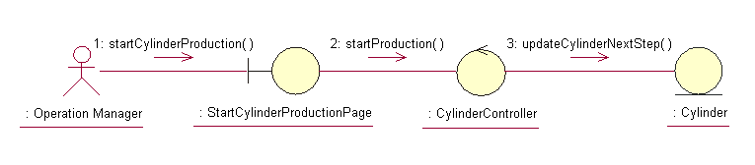

Participating Objects

Start Cylinder Production Page
This object renders the contents to allow authorized actors to initiate the cylinder production request. The Director, Department Manager and Operation Manager actors use this object.

Cylinder Controller
This object acts as the middleman between “Start Cylinder Production” Page and the Cylinder object. It will translate interactions with the view into actions to be performed by the Cylinder object.

Cylinder
This object stores the details concerning the cylinder information of the COMS.

Class Diagrams

Domain Class Diagram: Start Cylinder Production Process
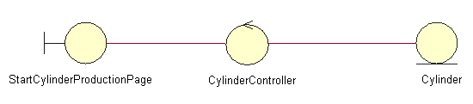

Derived Requirements
The Operation Manager PC keyboard and mouse will be used to enter cylinder production process information details (if any) and view all the system responses.

